Random Forest Regression is a type of an Ensemble Learning where we use combination of Machine Learning models .

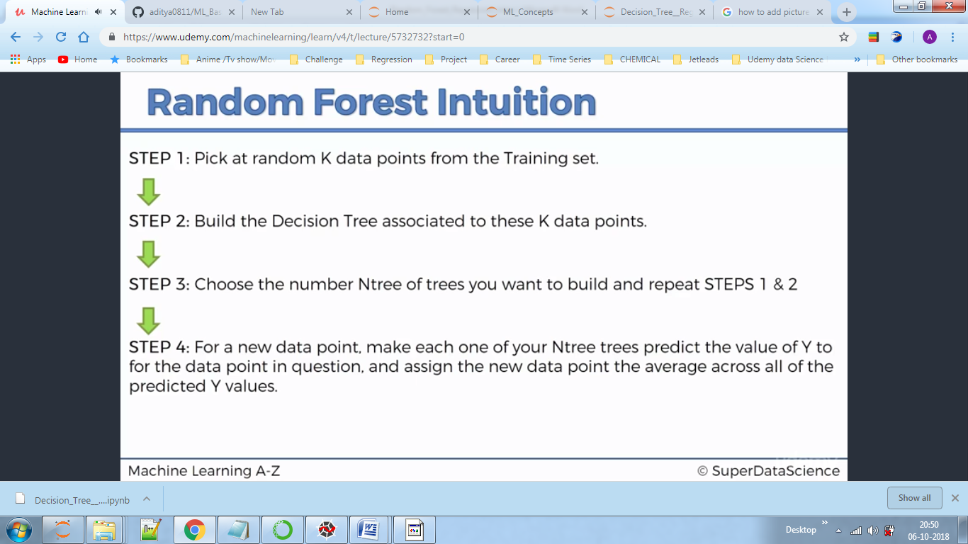

It is better than Decision tree as we are now taking average of predictions and therefore accuracy is improved.